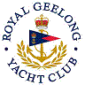 | Royal Geelong Yacht Club Inc.  Est 1859
Trophy Deed of Gift.

Trophy: | Ernest Brockman Memorial
Presented by: | E. Brockman & Son
Date: | 1964
For: | Combined Division Event so nominated Annually
Remarks / Revisions | Ern Brockman was a Club Captain and Life Member. With Bill Smith, maintained the Club during WW2, and conducted dinghy races.  Later, ran the Club’s racing until their deaths.  2008: Restricted to Division I
Click here for a List of Recipients
Mr Brockman was Proprietor of E. Brockman and Sons, Metal-Workers

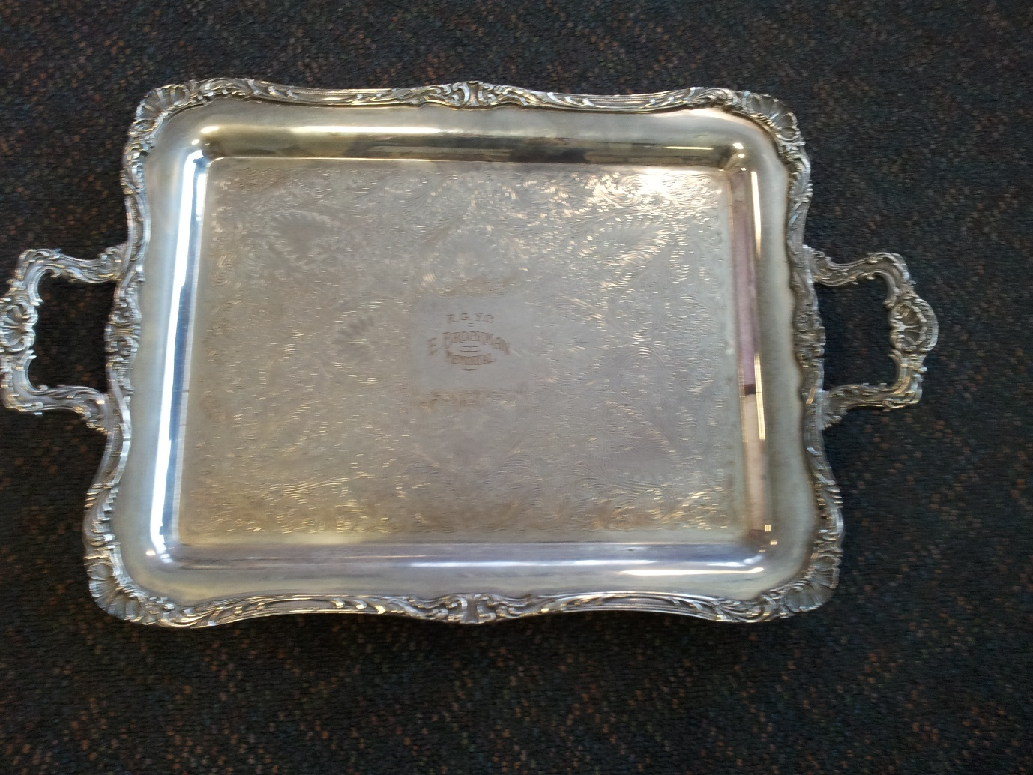

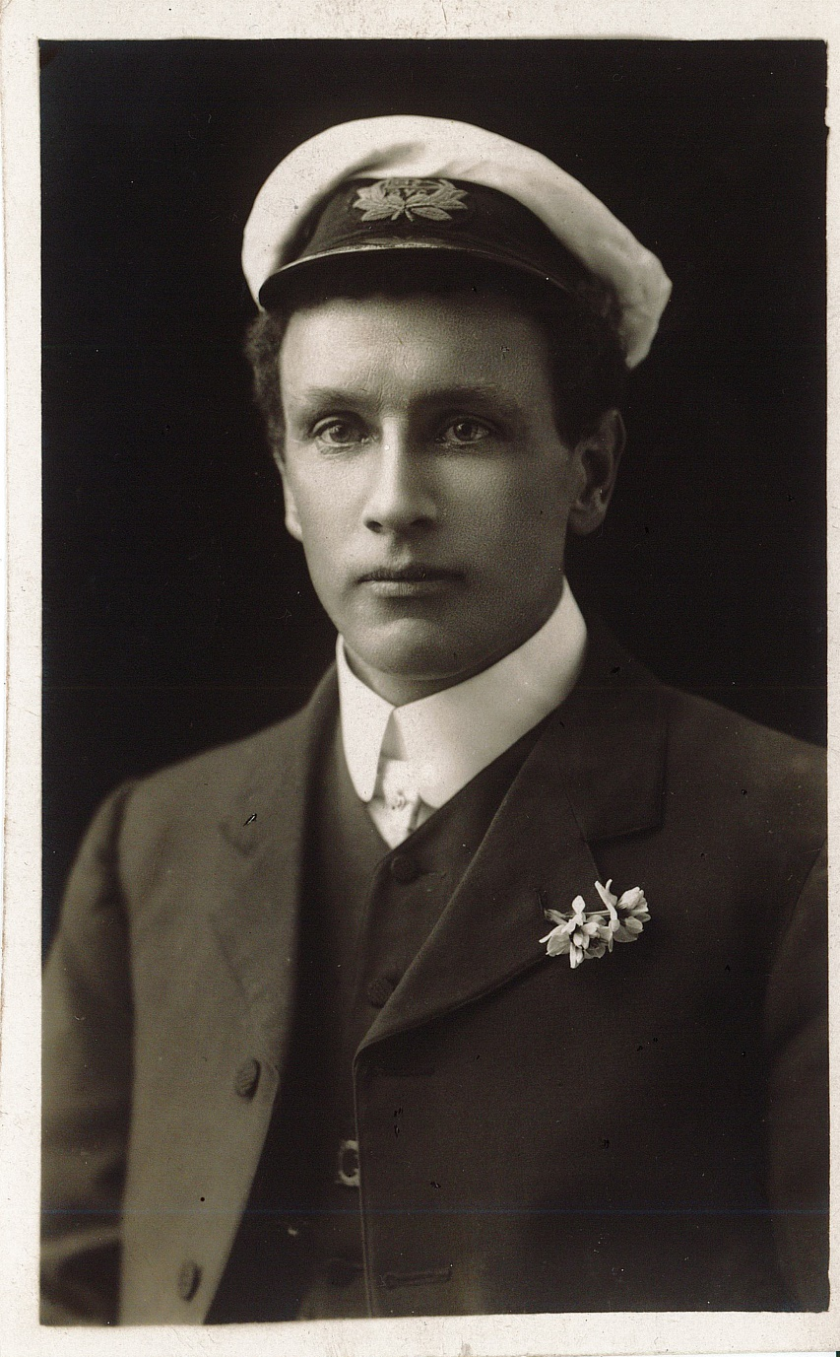

Photo of Ern Brockman

